INSTALLING YOUR 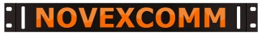MOUNTING BRACKETS
NOVEXCOMM RACK MOUNTS THOUSANDS OF ITEMS NEVER INTENDED FOR RACK MOUNTING, THIS SHEET WILL HELP YOU MOUNT YOUR ITEMS PROPERLY
OUR GENERIC 90 DEGREE “L” BRACKET KITS ARE DESIGNED TO FIT ALMOST ANYTHING:
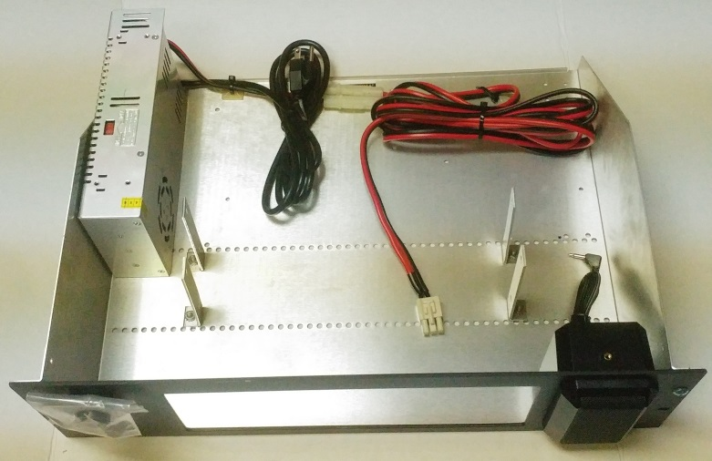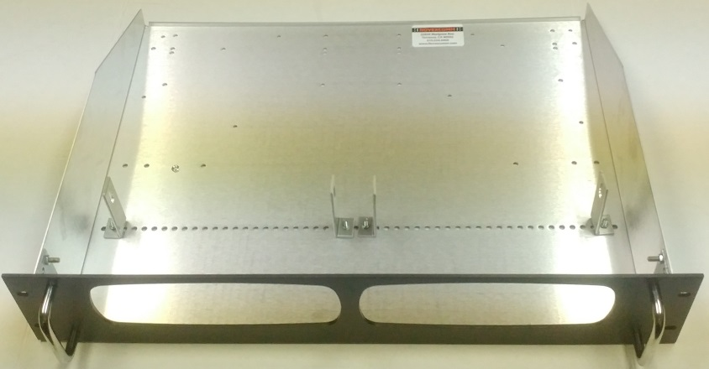
Loosely bolt the brackets to the item, slide through the front panel into place, mark and drill the holes and NOTE that the holes in the tray are for generic mounting of straps, not specific to any equipment.
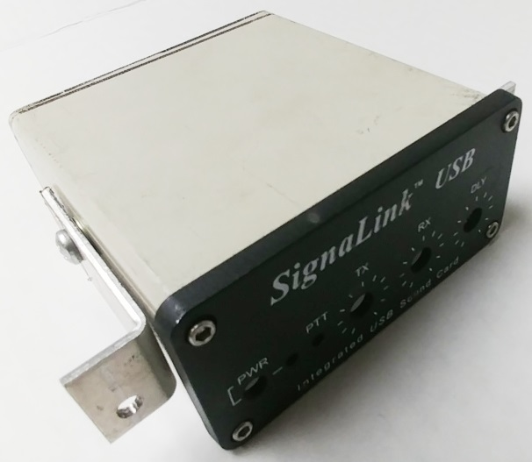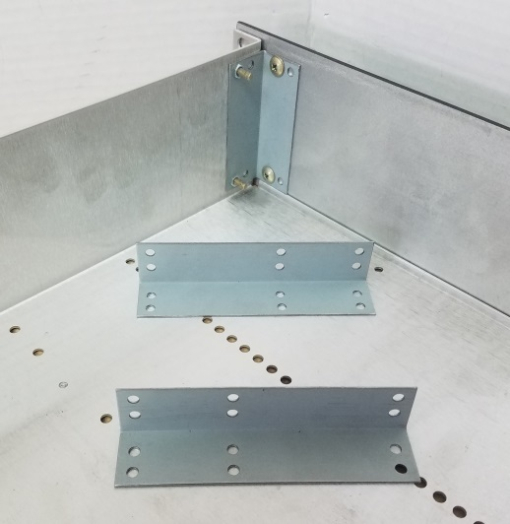
WANT TO BOLT THE PANEL TO THE TRAY FOR EXTRA STABILITY? Our optional corner bracket kit connects from the back of the HANDLE holes (if they are present) to the tray at the corners. If your design doesn’t have handles then this may well not be possible, verify it!
IF YOUR ITEM DOESN’T HAVE THREADED INSERTS THIS IS THE WAY TO RETROFIT: Threaded inserts, Rivet-Nuts or Riv-Nuts are similar to the common Pop Rivets. We offer threaded insert kits for one-time installation or you can buy a kit from discount supply houses for around $40-60 on the Internet
FOR SHELF-LESS MOUNTING ASK FOR THESE “WINGS”
